Temasek Polytechnic

School of Informatics and IT

**Diploma in Information Technology (IT)**

Project Plan

**Project Particulars**

|  |  |
| --- | --- |
| **Tutor** | Mr Qi Yutao |
| **Class** | P02 |
| **Project Title** | Delonix Regia Hotel Management System |

**Project Team’s Particulars**

|  |  |
| --- | --- |
| **Matric Number** | **Student Name** |
| **1301676A** | **Mohamed Nisar Faizal** |
| **1301183H** | **Ronald Ng** |
| **1300506A** | **Syazwani binte Saharoni** |
| **1307306I** | **Mervin Neo** |

Contents

1. Introduction 3

1.1. Objectives and scope of the project 3

1.2. Assumptions and constraints 4

1.3. Definitions and acronyms 4

2. Roles and responsibilities 4

3. Estimates and project schedule 5

3.1. Work breakdown structure 5

3.2. Project Schedule 6

3.3. Budget Summary 6

4. Risk Management Plan 7

5. References 7

# Introduction

## Objectives and scope of the project

Objectives-

The first objective of this project is make a booking system usable by both customers and staff. We want to implement a system where users (customers/staff in behalf of customers) can book rooms, view available rooms and its type and manage the bookings which are already made (i.e. Updating/Cancelling). The first objective will require a payment module to be installed and the staff registrations for their individual accounts. Second objective is to implement a housekeeping system. This system will help staff to see the cleaning schedules and room making requests/schedules of the hotel. Through this the service staff (i.e. Cleaners) can function efficiently so that the rooms are always prepared properly for guest usage. The third objective is to implement an online helpdesk where customers/guest are able to communicate with the hotel staff regarding enquiries in real time so that they can get their queries/doubts instantly solved.

Scope-

The features of the software system are mainly 4. First feature is hotel guests can view the available rooms and its type in the hotel by checking the system instantly through the website. Secondly, guests can book their preferred rooms in the hotel by themselves and update/delete their bookings in the system (e.g. Extend the booking by another day subject to its availability). They can do these by entering their particulars which are required by the hotel including making of payment. This 2 features can also be done by the hotel staff on behalf of the hotel guests/customers directly in the system itself. Thirdly is the housekeeping system where the staff in charge of the room maintenance services can identify the rooms in need of service/cleaning through the system and can inform the cleaners promptly so that they can be more efficient in their service schedules. Lastly is the online chat system for customers to communicate with the staff. Customers/guests can communicate with the staff of the hotel through the chat box in the website so that they can make enquiries instantly.

## Assumptions and constraints

Assumptions-

­The assumptions that our team made are:

1. The hotel has its own website but without a booking option.
2. There are currently no IT systems in the hotel.
3. The hotel allows advanced booking
4. The hotel does its daily operations on a manual basis (e.g. booking rooms by manual entry)
5. Credit/Debit payment is allowed

Constraints-

The constraints that the team expects to face are:

1. The availability of the labs as the labs might have been used for others’ lessons,
2. The other projects we have in hand which will take up a lot of our time
3. The group members’ different schedules will cost us to be inefficient as we are not able to work together most of the time.

## Definitions and acronyms

IT-Information Technology

CRUD- Create, Retrieve, Update & Delete

# Roles and responsibilities

|  |  |
| --- | --- |
| **Roles** | **Member/s** |
| Work Breakdown | Faizal |
| Project Scheduling | Ronald |
| Budget Planning | Syazwani |
| Risk Management Planning | Mervin |
| Booking System | Faizal & Syazwani |
| Housekeeping System | Ronald |
| Chat System | Mervin |

# Estimates and project schedule

## Work breakdown structure

|  |  |  |  |
| --- | --- | --- | --- |
| **Task** | **Completion Time** | **Phase** | **Member/s in charge** |
| Requirements/Specifications Gathering | 1st Week | 1 | Faizal, Syazwani, Ronald & Mervin |
| Database creation for Booking system and Housekeeping system | 2nd Week | 2 | Faizal, Syazwani, Ronald & Mervin |
| Prototype Booking System- CRUD Function | 3rd Week | 2 | Faizal & Syazwani |
| Prototype Booking System- Staff Account (Login function) | 4th Week | 2 | Syazwani |
| Prototype Booking System- Payment Module | 4th Week | 2 | Faizal |
| Prototype Housekeeping System- Coding (Creating an interactive dashboard making use of the Booking system and the Housekeeping Databases) | 3rd & 4th Week | 2 | Ronald & Mervin |
| Communications system- Coding (Installing a chat box plug in to allow communication through text) | 4th Week | 2 | Mervin |
| Prototype Checking with Mr. Wang | Start to Middle of 5th week | 3 | Faizal, Syazwani, Ronald & Mervin |
| Prototype Refinement | Middle of 5th to 7th Week | 3 | Faizal, Syazwani, Ronald & Mervin |
| Booking System- Implementation into website | 8th Week | 4 | Faizal & Syazwani |
| Communications System- Chat box (Implementation into website) | 8th Week | 4 | Ronald & Mervin |

## Project Schedule

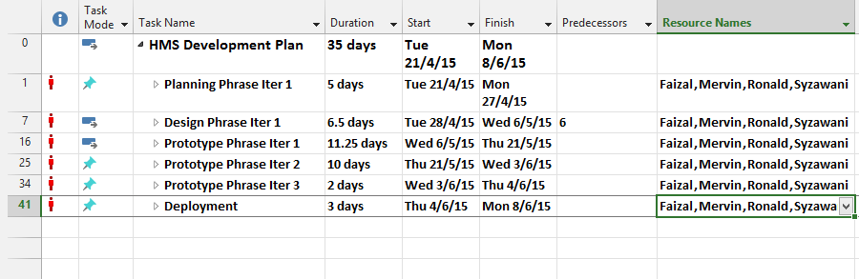

Full details will be in the .mpp file attached to the project.

## Budget Summary

**Manpower**

|  |  |  |
| --- | --- | --- |
| **Job** | **Duration of Project** | **Price** |
| Software Engineer | 8 weeks | $2, 500/month |

**Hardware**

|  |  |  |
| --- | --- | --- |
| **Resources** | **Model** | **Price** |
| Operating System (4) | Windows 8.1 | $219 |
| Laptop (4) | Lenovo ThinkPad X1 Carbon | $2324.93 |
| Hard Drive | Seagate Backup Plus Slim Portable Drive 500GB (Black) | $89 |
| Laser Printer | Brother HL-1110 Mono Laser Printer | $68 |

**Software**

|  |  |  |
| --- | --- | --- |
| **Resources** | **Model** | **Price** |
| Database | MySQL Standard Edition | $2646.80 |
| Software Development Platform | NetBeans IDE | - |

Total cost = (($2500 x 2) x 4) + ($219 x 4) + ($2324.93 x 4) + $89 + $68 + $2646.80

= **$32, 979.52**

# Risk Management Plan

The possible project risks are that there might sometimes be some bugs in the system which might cause the system to crash or not function as proper, the system might be hacked by other hackers and the data in the database might sometimes be corrupted. The likelihood of these risks are rather high especially when left unattended as bugs in the system may cause some inconvenient to customers and employees where they might experience problems like system crashing and system unable to process bookings. Also, the system might be hacked by hackers as the system contains private information of customers like their credit card numbers which the hackers would be able to access to these information if they successfully hacks into it and the database might sometimes be corrupted due to some other technical issues, which may result to loss of important information in the database. These risks can be solved or reduced by constantly updating the system to get rid of possible bugs that might be in the system, implement some anti-hack software to prevent hacking of the system and constantly backup the database so that even when the system’s database is corrupted, the data are backed up and the loss of data will be minimized.

# References

<http://www.microsoftstore.com/store/mssg/en_SG/pdp/Windows-8.1/productID.288728100>

<http://shopap.lenovo.com/sg/en/laptops/thinkpad/x-series/x1-carbon/>

<https://www.challenger.com.sg/products/sub_category/PORTABLE-HDD>

<https://www.challenger.com.sg/products/sub_category/PRINTER-LASER>

<https://www.mysql.com/products/>